**MINISTRY/ORGANIZATION NAME:** CDK Global.

**PROBLEM STATEMENT:** Portal for Farmers to sell the product at a better rate.

• Problem statement in Description:

1. System that provides farmers an interface to sell their product, and connect with the buyers all over India.

2. Simple interface that works on mobile, SMS to upload product details and respond via phone and SMS (taking care of digital divide).

3. Interface for anyone to buy the produce/vegetable – initially visit the place and buy or have courier service integrated to deliver the vegetables so Farmers can get a better price for their produce, no additional cost spent in marketing and delivery of goods, however they can choose to charge more by delivering the items themselves.

**TEAM NAME:** Agrocraft.

**TEAM LEADER NAME:** Abhishek Gupta.

|  |  |  |  |
| --- | --- | --- | --- |
| Name | Gender | Email id | Phone |
| Abhishek Gupta | Male | abhig0209@gmail.com | 8169193145 |
| Gladina Raymond | Female | rrcg2000@gmail.com | 9820835824 |
| Omkar Bhabal | Male | omkarbhabal11@gmail.com | 8828071232 |
| Calista Gonsalves | Female | gonsalvescalista21@gmail.com | 8369051225 |
| Ansh Chhadva | Male | anshmiteshchhadva@gmail.com | 9819104641 |
| Arpit Bhat | Male | arpitbhat48@gmail.com | 7666610976 |

**COLLEGE CODE:**

**IDEA/SOLUTION/PROTOTYPE:**

Agrocraft is an online portal with a pure vision to consolidate farmers and buyers who can both be consumers or restaurant owners, and abolish the system of middlemen.

**FARMER**

1. The farmers have to register on the **Multilingual portal** which allows the farmer to choose his preferred language, following which a **Verification team** will verify the legal documents and the quality of the products on site. With that being done, the farmer will now be **Certified** which makes him eligible to upload his products online after logging in. He will be familiarized with the statistics of the number of farmers in his domain and vicinity on the farmer homepage.
2. The farmer can insert his product, update/edit his product details and delete the product from the portal via the website, **SMS and Call system** (Call Centres). Along with the contact information of the buyer made available to the farmer to call and commune, the portal also provides a personalized **Chat Section** with the buyer which succours in bridging the gap between remote farmers and buyers. The farmer will be **notified via SMS/website** when a buyer buys his product.
3. When the farmer enters his price for his product, he will be shown the **prevalent market price** **range** for that particular product which assists in giving him a rough estimate, with the help of algorithms.
4. The farmer can keep track of all his previous transactions in his account on the website.

**BUYER**

1. On the other hand, once the buyer is registered and logged in, he gets to access and buy all the products put up by the various farmers according to his choice. If a buyer has a preference of any location, from where he desires his product to emerge from, he can **search the products on the basis of location (state and district), and price**, thereby implementing the **filter system**.
2. The **review system** backed by the feedback from the previous customers and the **bestsellers feature** enables the buyer to buy the best products and the **reporting system** helps to maintain mutual integrity on the platform. If five negative reviews is noted against a particular farmer, he no longer stands eligible to use the portal. The verification team will respond and once again verify, after which necessary actions would be taken.
3. If there’s any product that the buyer needs on a regular basis, he can use the **subscription feature** by which he has to order that product only once and specify the duration and also the days he requires the product. The **recommendation system** displays the product frequently bought by the buyer, and also specifies the products bought together which helps in easy use of the website.
4. If **scarcity** of a particular product arises at any instant of time, at a particular location, the buyer will be given **suggestions of locations closest to his vicinity where the product is available.**
5. **s**

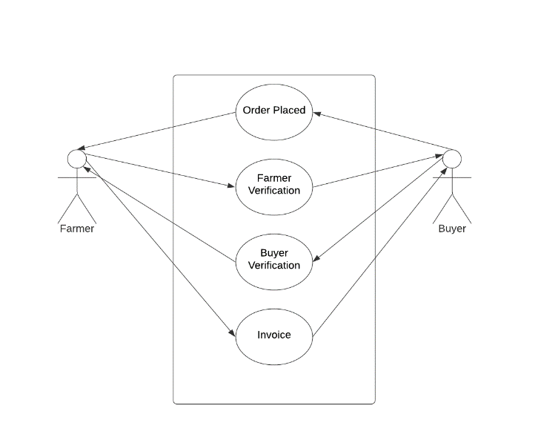

**TECHNOLOGY STACK:**

1. Web Technology: - HTML, CSS, JavaScript, AJAX, Bootstrap Django and nodeJS.

2. Programming languages: - Python.

3. Mobile Development:-Android Studio, Android SDK and Jellybean version and above.

4. Backend Development:-My SQL Database and Firebase.

**USE CASE DESCRIPTION:**

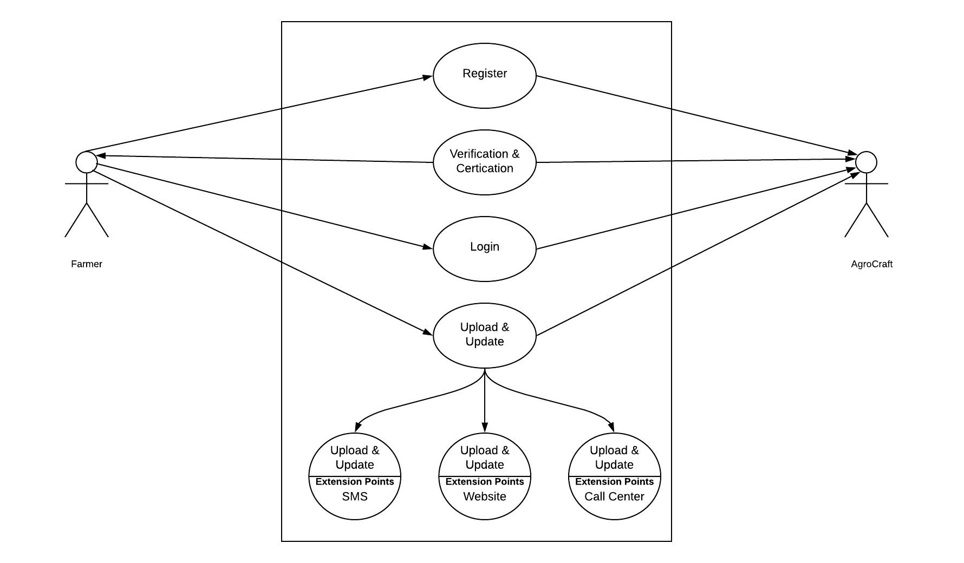

**DEPENDENCIES:**

1. The farmer must possess a basic phone.

2. This application can be installed in all devices having Android version Jellybean and higher.

3. An online portal generated shall require IE v9 or higher, Google Chrome, Mozilla Firefox, or any other web browser.

**SHOWSTOPPERS:**

1. Call Centres.

2. SMS

3. Farmer profits increases owing to the fact that farmers sell their products at market rates, eliminating the middleman.

4. Buyers can get their hands directly on fresh products according to their choice of product, variety and time, straight from the fields in reasonable prices.

5. Multiple farmers (many of which reside in remote areas) get in direct touch with buyers in capital cities and the prices are negotiable between them with no involvement of the admin whatsoever.